**Project 2**

**DEPLOY A STATIC WEBSITE ON AMAZON S3**

**INTRODUCTION**

Amazon simple storage service (S3) primary focus is general object storage in the cloud, similar to Google Drive or Dropbox. In this case, S3 is for software-oriented applications which you can use to store anything from images, hosting static websites, source code, spreadsheets, and so on.

Static Website: A static website delivers content in the same format in which it is stored. No server-side code execution is required. For example, if a static website consists of HTML documents displaying images, it delivers the HTML and images as-is to the browser, without altering the contents of the files

Static websites can be delivered to web browsers on desktops, tablets, or mobile devices. They usually consist of a mix of HTML documents, images, videos, CSS style sheets, and JavaScript files. Static doesn’t have to mean boring—static sites can provide client-side interactivity as well. Using HTML5 and client-side JavaScript technologies such as jQuery, AngularJS, React, and Backbone, you can deliver rich user experiences that are engaging and interactive.

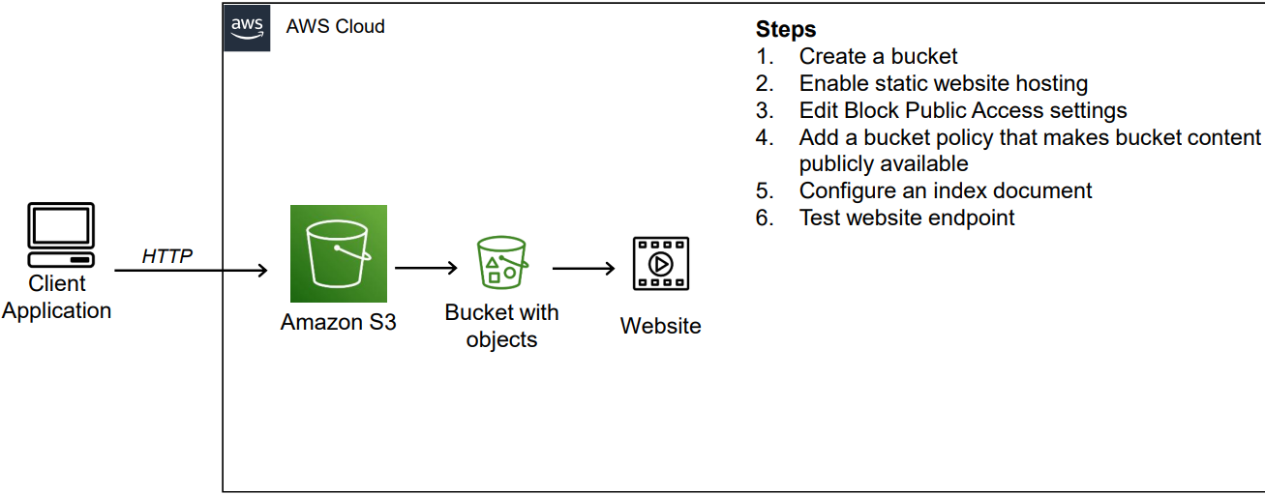

**Steps**

**Step 1: Creating my S3 bucket**

* Sign in to the AWS Management Console.
* Open the Amazon S3 console.
* Click on Create bucket.
* Enter the name of the bucket as **uploadbucket20.**
* Choose a Region i.e. Asia Pacific (Mumbai) ap-south-1.
* Under “Block Public Access settings for this bucket” section, uncheck the “Block all public access” checkbox and accept the acknowledgement.
* Select “Disable” for Bucket Versioning.
* Under “Default encryption” section, click on disable for Server-side encryption.
* Click on “Create bucket”.

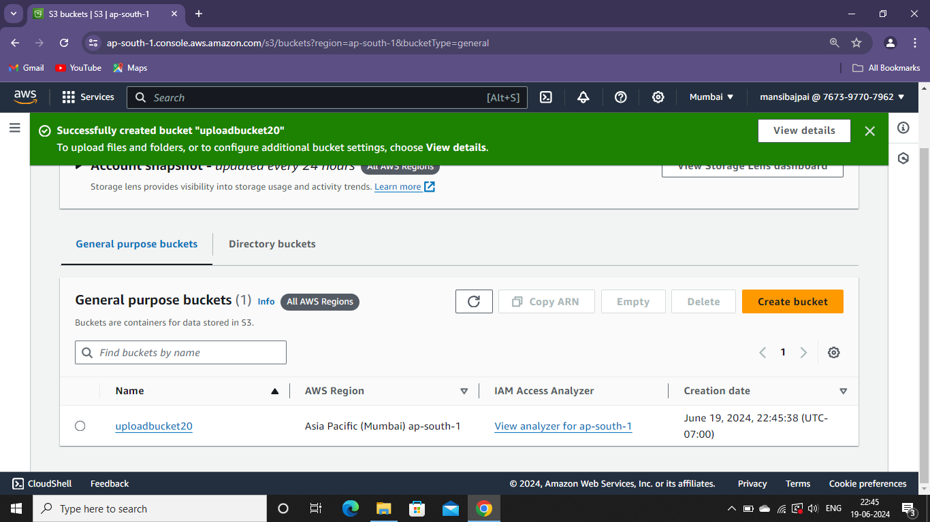

**2: Enabling static website hosting**

* In the Buckets list, choose the name of the bucket that you want to enable static website hosting for (**uploadbucket20)**
* Click on the “Properties” tab.
* Scroll down to the “Static website hosting” section and click on its Edit button.
* Under Static website hosting, choose Enable. Also, select Host a static website for the Hosting type. In Index document, enter the file name of the index document, typically index.html.
* Click on “Save Changes”. You should see the following next.

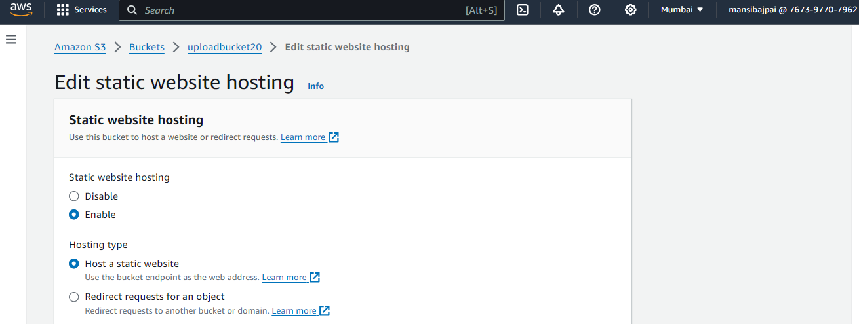

**Step 3: Securing my S3 bucket through IAM policies**

* Under Buckets, click on the name of your website bucket.
* Click on the “Permissions” tab.
* Under Bucket Policy, choose Edit.

To grant public read access for your website, copy paste a codein the Bucket policy editor. Make sure to replace bucket-name with the name of your bucket.

* Scroll down and click on “Save changes”.

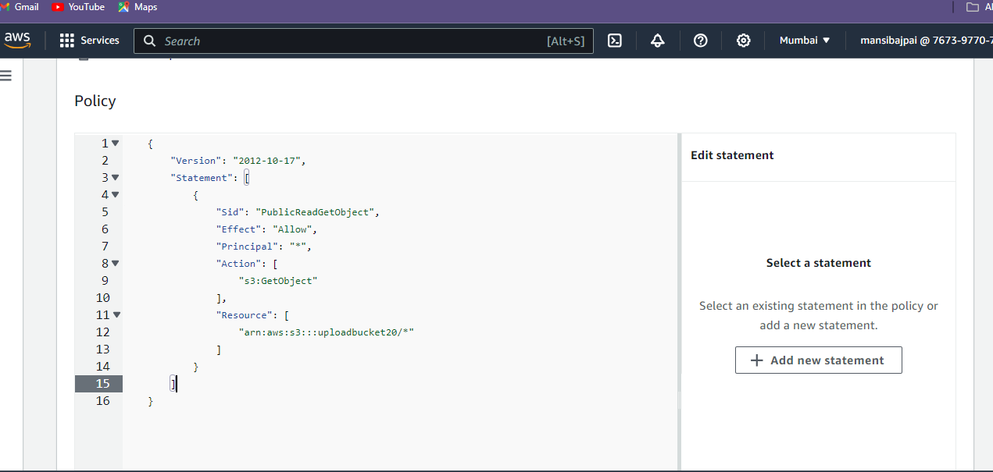

**Step 4: Uploading web files to my S3 bucket**

* Under Buckets, click on the name of your website bucket.
* On the Objects tab, you can see that the bucket is currently empty, click on the Upload button.
* This should take you to the Upload page. Click Add files to add the website files and use Add folder to add the website folders.
* Now after uploading the file you will see your file in the object section of your bucket.

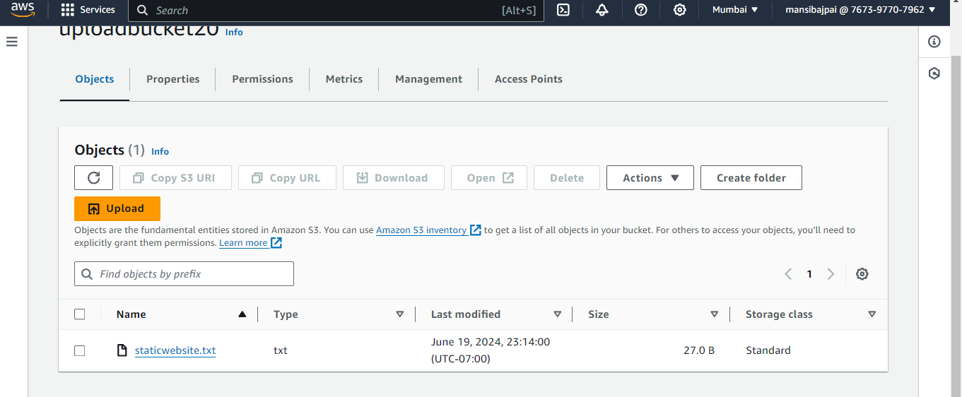

**Step 5: Testing my website endpoint**

* UnderBuckets, click on the name of your website bucket.
* Click on the “Properties” tab.
* Scroll down to the “Static website hosting” section and click on your endpoint URL.
* Now copy the object URL for running it in your browser.

